**Practical No 6 Date:** 08 / 08 / 2023

**Title:** Write a Python Program to implement the following:

a) Create a phonebook by taking N names and phone number from input, store as dict of

(name, number). Then ask user to enter a number and print the name of person after

searching for the number.

b) Print the reverse of the given integer using function.

c) Write a function is_prime() that returns 1 if the argument passed to it is a prime number and 0 otherwise.

d) Write a function that accepts an integer between 1 to 12 to represent the month number and displays the corresponding month of the year.

e) Write a program in python to create a class which can accept N numbers and functions to read data, sort data and display it.

**Description:**

**Functions in Python:**

Functions are designed to process the input data and produce the output as per requirement as shown below.

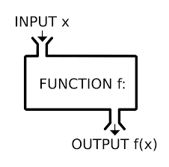

* Can be assigned to a variable
* Can be passed as a parameter
* Can be returned from a function
* Functions are treated like any other variable in Python, the def statement simply assigns a function to a variable

**Syntax:**

*def function_name(list of parameters) :*

*statements*

**Example:**

*def max(x,y) :*

*if x > y :*

*return x*

*else :*

*return y*

**Class:**

Class is a way to bind data with its member functions. A class consists of – variable and functions on these variables. It is one of the way of hiding the data from the user

Two Special functions

* Constructor
* Destructor

**Syntax:**

*Class classname:*

*Def __init__(self)*

*#Stements in constructor*

*Def functionname(parameter list)*

*#Statements*

**Example:**

*class Foo:  
 def __init__(self):  
 self.member = 1  
 def GetMember(self):  
 return self.member*

**Program Code:**

**1.**

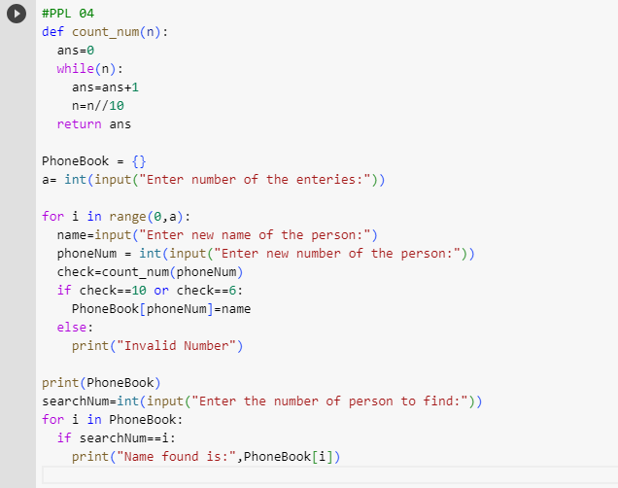

2.

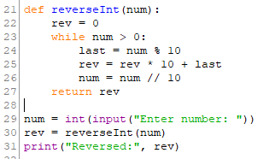

3.

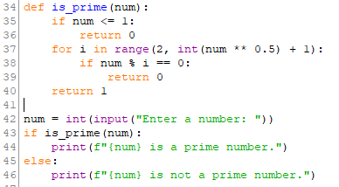

4.

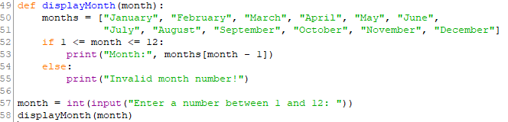

5.

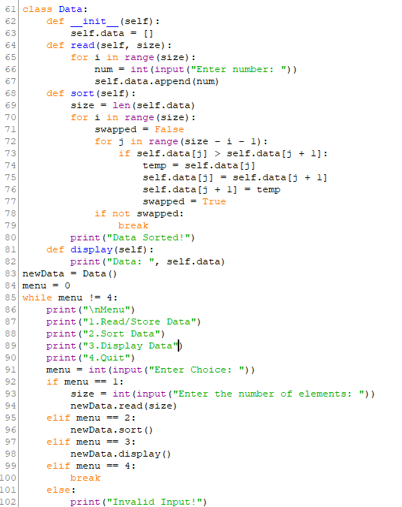

**Input and Output**

**1.**

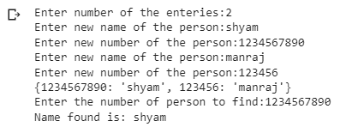

2.

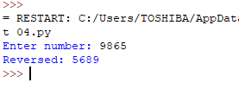

3.

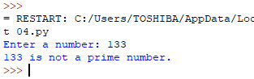

4.

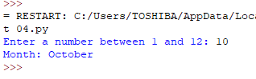

5.

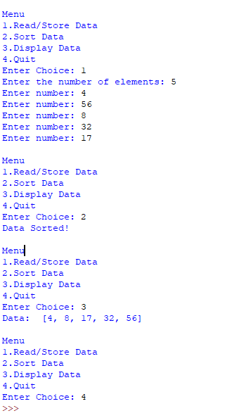

**Conclusion:** Thus we have implemented various functions and class in Python.

**Practice programs:**

1. Write a Python Program to validate the date without using any library function.
2. Write a Python program to which show the usage of high order functions like *map()* and *filter()*.